Software Requirements Specification

Version 1.0

August 15, 2018

Library Management System

Shovan Kumar Behera

Rupsita Parida

Shakti Prasad Mishra

Submitted in partial fulfillment

of the requirements of

Software Engineering

# Table of Contents

Table of Contents i

1.0. Introduction 1

1.1. Project Description 1

1.2. List of Actors 1

1.3. Scope of Projects 2

1.4. References 2

2.0. Overall Description 4

2.1 Functional Requirements 5

2.1.1 Use Case 5s

2.1.2 Entity Relationship Diagrams

2.1.3 Data Flow Diagrams

2.2 Non-Functional Requirements 15

2.2.1 System Requirements

2.2.2 Performance Requirements

2.2.3 Security Requirments

2.2.4 Database Requirments

2.2.5 Safety Requirments

1. **Introduction**

**1.1 Project Description**

The purpose of this document is to present a detailed description of the Library Management System. It will explain the purpose and features of the system, the interfaces of the system, what the system will do, the constraints under which it must operate and how the system will react to external stimuli. This document is intended for both the users and administers of the system and will be proposed to the educational institutions for its approval.

**1.2 List of Actors**

Admin (Librarian), Issuer (Student/ Teacher)

**1.3 Scope of Projects**

This software system will be a Library Management System for a university. This system will be designed to manage the issuing of books efficiently by providing tools to assist in automating the book issue, return date and generation of fine, if any, which would otherwise have to be performed manually. By maximizing the librarian’s work efficiency the system will meet the users’ needs while remaining easy to understand and use.

More specifically, this system will keep a track of what and how many books a person issues on a regular basis. It’ll also keep a record of the number of copies of individual books that the library owns and currently has available for issuing. The system will also make it easy for the users to find their choice of books by categorising the books under authors, subjects and editions. The system also contains a relational database for all issuers and books.

**1.4 References**

Example: IEEE. IEEE Std 830-1998 IEEE Recommended Practice for Software Requirements Specifications. IEEE Computer Society, 1998.

1. **Overall Description**

**2.1 Functional Requirements**

**2.1.1 Use Case**

Example: Search Book

Diagram:

RETURN

Issuer

ISSUE

Brief Description:

The Issuer searches for a book in the library and issues it if available.

Initial Step-By-Step Description:

For Issue:

The Issuer searches for a book by book name, author name, subject, and edition.

If available the Issuer goes to the Librarian to issue the book.

The system displays the information of the book i.e., book id, book name, author, subject and total no. of issues to the Librarian.

The system displays the information of the Issuer i.e., Name, Book Id, Date of Issue, Date of return, Fine if any by the Id of the Issuer.

If more than three books haven’t been returned, the system rejects to issue any book else the system allows proceeding further.

The Librarian enters the details in the Issuers database and decrements the availability column of the book in Book database.

The Issuer can now take the book.

For Return:

The Issuer goes to the Librarian to return the book.

The system displays the information of the book i.e., book id, book name, author, subject and total no. of issues to the Librarian.

The system displays the information of the Issuer i.e., Name, Book Id, Date of Issue, Date of return, Fine if any by the Id of the Issuer.

If the Issuer is finned with some amount, he/she has to return the book along with the challan.

The Librarian enters the return date in the Issuers database and increments the availability column of Book in Book database.

The Issuer can now issue some other books.

**2.1.2 Entity Relationship Diagrams**

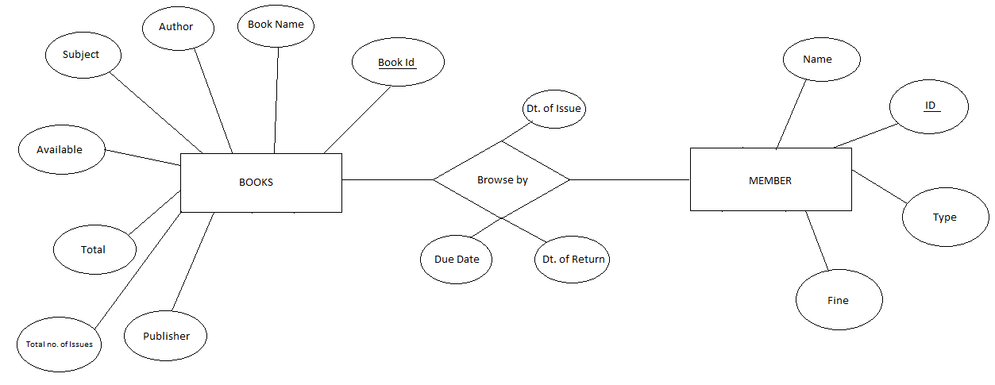

**Member Data Entity**

|  |  |  |  |
| --- | --- | --- | --- |
| **Data Item** | **Type** | **Description** | **Comment** |
| Member Id | Test | Id of the Member | Key value |
| Name | Text | Name of the Member |  |
| Type | Text | Student/Teacher | Issuer is Student or Teacher |
| Book Id | Text | Id of the Book | Unique Id for each book |
| Date of Issue | Date | Date when the book was issued |  |
| Due Date | Date | Date till no fine | After due date the member would be charged with some fine |
| Date of Return | Date | Date when the book was returned |  |
| Fine | Integer | Amount to be paid as fine due to late return |  |

**Book Data Entity**

|  |  |  |  |
| --- | --- | --- | --- |
| **Data Item** | **Type** | **Description** | **Comment** |
| ID | Text | ID of the book | Used as key |
| Name | Text | Name of the book |  |
| Author | Text | Author of the book |  |
| Publisher | Text | Publisher of the book |  |
| Subject | Text | Book belongs to which subject |  |
| Availability | Boolean | If the book is available or not | True or False |
| Total | Integer | Total no of books | Total no of books available in library of specified type |
| Total no. of issues | Integer | Total no. of issues till day | Total no of issues till day of specified type |

**2.1.3 Data Flow Diagram**

ISSUE/RETURN BOOK ENTRY

MANAGES BOOK AND MEMBER DATABASES

UPDATED BOOK AND MEMBER DATABSE GENERATION

USER ACCOUNT MAINTENANCE

LIBRARY MANAGEMENT SYSTEM

LIBRARIAN

MEMBER

BOOK BANK DETAILS REPORT GENERATION

ISSUED AND RETURNED BOOKS REPORT GENERATION

**2.2 Non Functional Requirements**

**2.2.1 System Requirements**

**2.2.2 Performance Requirements**

**2.2.3 Security Requirements**

**2.2.4 Database Requirements**

**2.2.5 Safety Requirements**